**Customer File ICONS**

The Push Pin Icon in A-F-1 is strictly for customer. The Push Pin Icon in O-U-1 is strictly for Orders.  
The BOOK Icon in A-F-1 has 3 options.

1. Customer Notes which are typed notes that only are displayed in the customer file.
2. Group Notes which are group by grouped defined in N-C menu.

We can program logic for specific groups.  
For example, the Group = PO can be added for Vendors under V-F-1, which transfer to every PO for that Vendor.

1. Department Notes for machines.  
   Notes by machine added in the customer file will transfer to all new estimates and print on the job ticket.

The Department Notes are displayed under the FOUNTAIN PEN Icon in estimating and Order Entry.  
But they currently don’t popup during order entry.

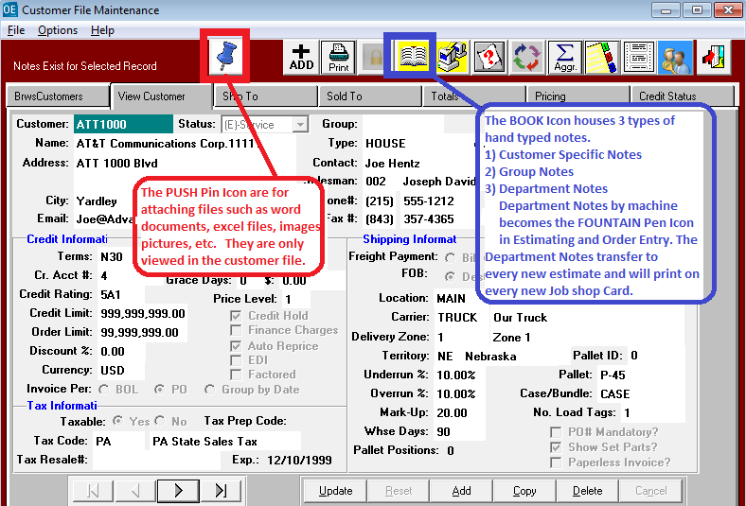

**ESTIMATE ICONS**

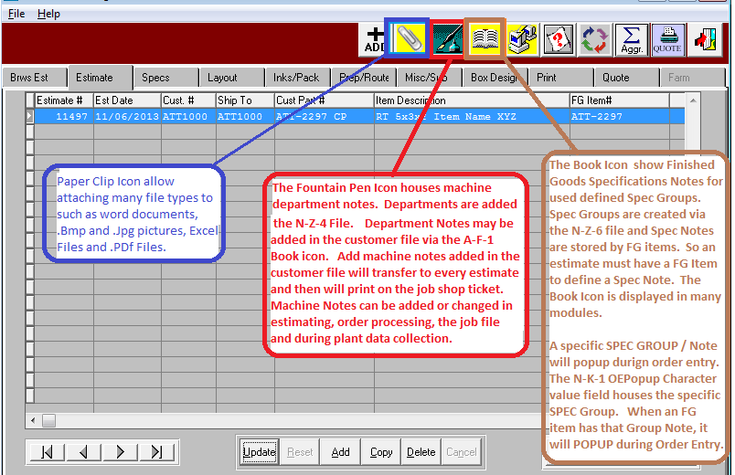

**Finished Goods Spec Notes Icon**

The N-K-1 OEPOPUP is a popup by Finished Goods Items for a specific SPEC CODE GROUP via the BOOK icon.  
The BOOK ICON allows adding Spec Notes in Estimating, Order Entry and FG item File.  
The Notes are all saved in the I-F-1 Item File under the BOOK ICON.  
This was originally designed for Overrun Inventory.  
The SPEC CODE Groups are defined under menu N-Z-6  
Below I have created the Code = OP.  
For Specific FG items,  The Note will Popup when adding or changing this specific FG item.

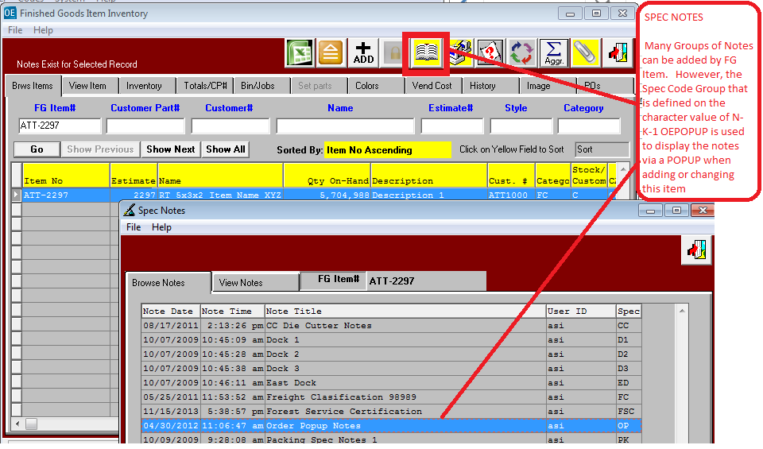

**Order Entry ICONS**

ORDER ENTRY ICONS for Notes and Attachments

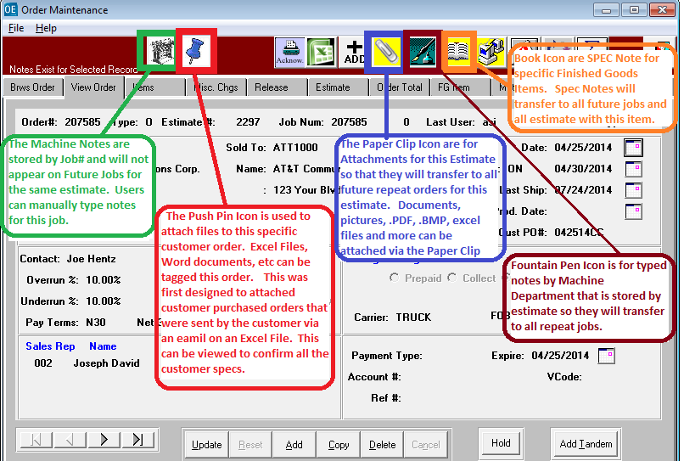

N-K-1 OEPPOP

ORDER ENTRY POPUP of SPEC NOTES defined by FG Item Code

